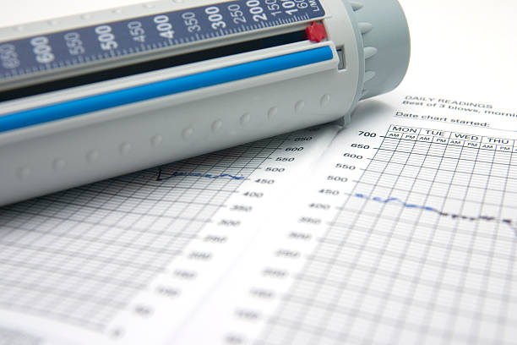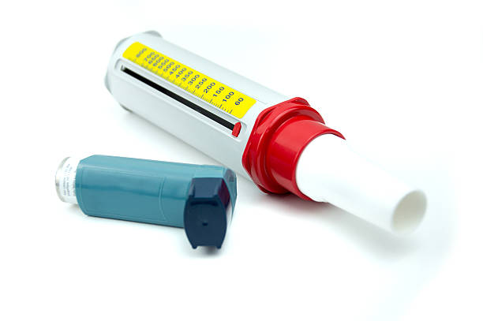

Book online on behalf of a patient at;

<https://gma.advhc.net/AWA/Login.aspx>

Please contact EPiC 24 if you have issues with your log in (epic.24@nhs.net)

**OPERATIONAL HOURS**



**THE SALFORD ACUTE SURGE HUB IS OPENING**

**15th DECEMBER 2023**

**WHAT IS THE HUB**

**HOW TO BOOK**

**WHO IS ELIGIBLE**

Adults and children who meet the same day criteria who need a face-to-face examination

*. Please see exclusions

Support for GP Practices across Salford to help alleviate pressures from the increasing number of patients presenting with Acute Urgent Primary Care Symptoms.

Patients can be booked in by the GP practice for a face to face assessment at the clinical hub.

From Little Hulton District Centre,

Haysbrook Avenue, Manchester M28 0AY

Monday to Friday: 9am-6pm